Tiffi Westcott

Relational Database – Open Artifact // archaeological-analytics.com

10/18/17

**Summary/Description:**

Archaeologists are notoriously known for posting photos of artifacts on social media platforms such as Instagram with hopes to crowd source their find. However fortuitous this may prove in some situations, asking amateurs for their knowledge most likely will not bring the results needed. There is not any database to date that is a go-to for artifacts and professional knowledge that would aid in field artifact identification.

Open Artifact of Archaeological Analytics is a trailblazing company in the field as they are trying to accomplish this task which will better serve material culture researchers across Canada and the United States. Professional archaeological and historical researchers should be able to utilize this in the field or in the lab and based on their diagnosis, discover more information about the diagnostics, material, object, and time period.

The public should be able to browse the database for sheer enjoyment or for their own independent research.

The goal in the future is to make this database website friendly, and in the layout of how an ecommerce website is set up like Best Buy. For now, I will be developing in Microsoft Access (for ease of use) the starting point in which future database developers can use.

**Goal/Mission Statement:**

The goal of this project is to create a database for Open Artifact that will act as guide for archaeologists to identify material culture, and for the general public to engage in independent research.

**General Objectives:**

The information that will be collected to be entered into the relational database will come from the staff at Archaeological Analytics through their own research which will include:

* Diagnostics – these are the specific details of each artifact. For example, a “Levana Projectile Point” has an incurvate base which would be a diagnostic of the artifact.
* Material – a material like “glass” or “ceramic” would be listed under this table
* Time – time periods would be listed on this table.
* Object – this would list objects like “bottle” or “bowl”. This difference between this table and the other tables is that each object listed in this table would have multiple diagnostics, one to a few materials, and a single time period.

**Class Objectives:**

The classes, their attributes and their primary keys (italics)/foreign keys (underline) will be as follows:

Object

(pk) *objectID*:

(fk) materialID:

(fk) timeID:

(fk) diagnosticID:

objectName:  
 creationDate:

updateDate:

Material:

(pk) *materialID:*

materialName:  
 creationDate

updateDate

Diagnostic:

(pk) diagnostic*ID:*

diagnosticName:

(fk) materialID:

creationDate:

updateDate:

Time:

(pk) *timeID:*

timeName:

creationDate:

updateDate:

Several relationships:

Object has a material or more; material has more than one object (n..*) (object can have more than one material)

Object can have one time period; a time period can have many objects (1..*)

Object can have many types; one type can have many objects (*..*)

**Use Case Diagram:**

Use Case: Perform research with no written documentation

Definition: Can be performed by users and contributors. This allows for research to be performed based on visual interpretation

Use Case: Perform research with knowledge of object and are looking for more information

Definition: Can be performed by users and contributors. This allows for the research to be performed based on visual interpretation and written knowledge.

Use Case: View database for people who want to contribute to database

Definition: Can be performed by users and contributors. This allows for the users who are just browsing and may be interested in contributing and the contributors who are, will or have been contributors to add to the database’s wealth of knowledge.

Use Case: Browse for general public browsing

Definition: Can be performed by users and contributors. This allows for the general public who may be general users or contributors to browse the site just to look at the material culture available.

Use Case: Perform updates to content

Definition: Can be performed by Database Manager or Founder. This allows for the administrators to edit content and update information that is in the database.

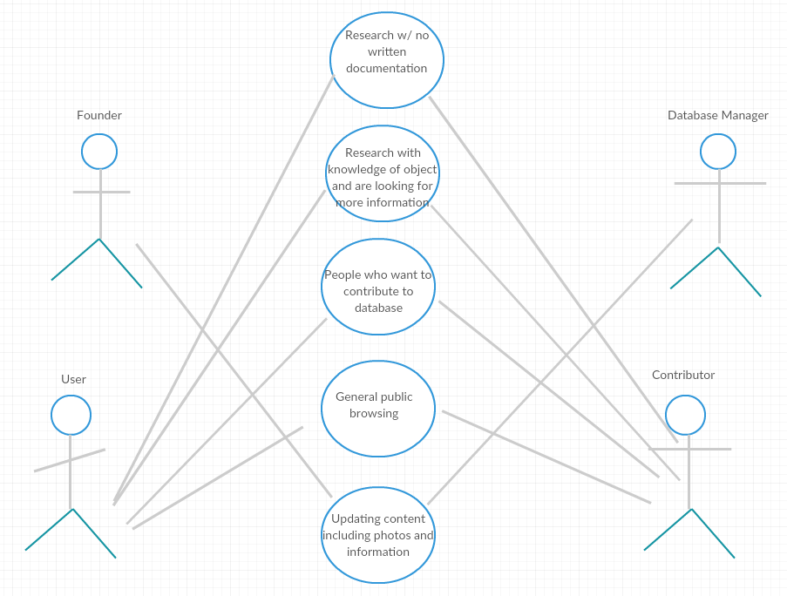

**Data Model:**

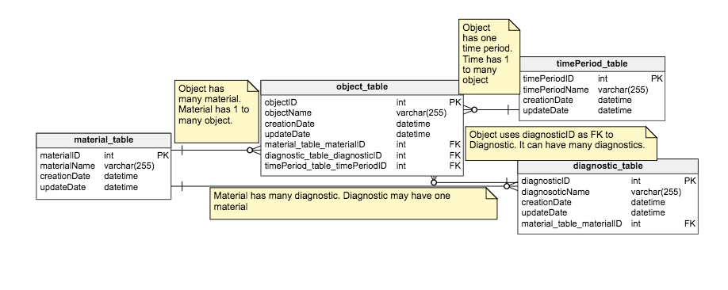

**SQL Triplets:**

*SELECT . . . FROM . . .*

1. From the diagnostic table, select the diagnostic names.
2. SELECT diagnosticName

FROM diagnostic_table;

1. diagnosticName:

Side-notched

Incurvate base

Straight stemmed

Side notched

Straight stemmed

*SELECT . . . FROM . . .*

1. From the material table, select the material names.
2. SELECT materialName

FROM material_table;

1. materialName:

stone: chert

stone: flint

*SELECT . . . FROM . . . WHERE*

1. From the time period table, select the time period name which goes by the name of “early archaic.”
2. SELECT timePeriod_table.[timePeriodName]

FROM timePeriod_table

WHERE timePeriodName = ‘early archaic’;

1. timePeriodName

early archaic

*SELECT . . . FROM . . . WHERE*

1. From the material table, select the material name which goes by “stone: chert.”
2. SELECT material_table.[materialName]

FROM material_table

WHERE materialName = ‘stone: chert’;

1. materialName

stone: chert

*SELECT . . . FROM . . . WHERE . . . ORDER BY*

1. From the diagnostic table, select all where the diagnostic name is “straight stemmed”” and order by descending.
2. SELECT *

FROM diagnostic_table

WHERE diagnosticName = ‘straight stemmed’

ORDER BY diagnosticName DESC;

1. diagnosticID | diagnosticName | materialID | creationDate | update date

5 | straight stemmed | 1 | 11/24/17 |

*SELECT . . . FROM . . . WHERE . . . ORDER BY*

1. From the time period table, select all where the time period name is “late archaic”” and order by ascending.
2. SELECT *

FROM diagnostic_table

WHERE diagnosticName = ‘late archaic

ORDER BY timePeriodName ASC;

1. timePeriodID | timePeriodName | | creationDate | update date

3 | late archaic | 11/24/17 |

*SUBQUERY*

1. From the time period table Query which asks the database to return the time period table and its names, select the time period name from the time period table where the TP name is early archaic.
2. SELECT timePeriod_table.timePeriodName

FROM timePeriod_table

WHERE timePeriodName IN (

select timePeriodName

from timePeriod_table

where timePeriodName = 'early archaic';)

1. timePeriodName

early archaic

*SUBQUERY*

1. From the diagnostic table Query which asks the database to return the time period table and its names, select the diagnostic name from the diagnostic table where the diagnostic name is stemmed base.
2. SELECT diagnostic_table.diagnosticName

FROM diagnostic_table

WHERE diagnosticName IN (

select diagnosticName

from diagnostic_table

where diagnosticName = stemmed ‘base’;)

1. timePeriodName

stemmed base

*JOIN*

1. From the material table, please take the diagnostic name from the diagnostic table and the material name from the material table and join on the diagnostic table which means that the material ID from the material table is equal to the material ID from the diagnostic table.
2. SELECT diagnostic_table.diagnosticName, material_table.materialName

FROM material_table INNER JOIN diagnostic_table ON material_table.materialID = diagnostic_table.materialID.Value;

1. Diagnostic table | material table

Incurvate base | stone: chert

Side notched | stone: chert

Straight stemmed | stone: chert

Side- notched | stone: flint

Straight stemmed | stone: flint

*JOIN*

1. From the time period table, inner join on the object table with object name from the object table and time period name from the time period table. This then dictates that on the time period table, the time period id is equal to the timeperiod id value.
2. SELECT object_table.objectName, timePeriod_table.timePeriodName

FROM timePeriod_table INNER JOIN object_table ON timePeriod_table.timePeriodID = object_table.timePeriodID.Value;

1. Object_table.objectName | timePeriod_table | timePeriodName

Levana point | middle/late woodland

Scottsbluff type I point | early archaic

Bare island point | late archaic